R.R. MORARKA PUBLIC SCHOOL, DWARIKESH NAGAR, DIST. BIJNOR
CBSE BOARD RESULTS CLASS XII – 2023
Toppers in Science Stream:
 |  | ENG | PHYSICS | CHEM | MATHS | Biology | IP | PHE | TOTAL | %age
 |  | (100) | (100) | (100) | (100) | (100) | (100) | (100)
1 | NISHI RAJPUT | 100 | 95 | 95 | ----- | 96 | ----- | 98 | 484 | 96.80
2 | MAHI MANGAL | 99 | 95 | 95 | ----- | 95 | 97 |  | 481 | 96.20
3 | DIVYANSH NAMDEV | 93 | 95 | 95 | 95 | ----- | ----- | 97 | 475 | 95.00
4 | KANISHKA | 96 | 95 | 95 | 93 | ----- | ----- | 96 | 475 | 95.00
5 | ANSHUL RAJPUT | 97 | 95 | 95 | 94 | ----- | ----- | 93 | 474 | 94.80
6 | ANUBHAV GUPTA | 92 | 95 | 94 | 92 | ----- | 99 | ----- | 472 | 94.40
7 | NETRA CHAUDHARY | 94 | 86 | 93 | ----- | 94 | 96 | ----- | 463 | 92.60
8 | KSHITI SHARMA | 98 | 93 | 92 | 80 | ----- | 99 | ----- | 462 | 92.40
9 | NIKUN CHAUHAN | 96 | 95 | 95 | 83 | ----- |  | 93 | 462 | 92.40
10 | PRANAV KUMAR RANA | 93 | 95 | 85 | 95 | ----- |  | 92 | 460 | 92.00

R.R. MORARKA PUBLIC SCHOOL, DWARIKESH NAGAR, DIST. BIJNOR
CBSE BOARD RESULTS CLASS XII 2023

Toppers in Commerce Stream:
Sr. No. | Candidate's Name
Sr. No. | Candidate's Name | ENG | ECO | B.ST | ACCT | APP. MATHS | PHE | IP | TOTAL | %age
 |  |  |  | TOTAL | ACCT | APP. MATHS | TOTAL | TOTAL | (500) | %age
Sr. No. | Candidate's Name | (100) | (100) | (100) | (100) | (100) | (100) | (100) | (500) | %age
1 | DIVYAM AGARWAL | 100 | 96 | 97 | 100 | 90 |  |  | 483 | 96.60
2 | DHRUVIKA BISHNOI | 95 | 99 | 93 | 90 |  |  | 98 | 475 | 95.00
3 | ARTH AGARWAL | 95 | 100 | 91 | 95 | 79 |  |  | 460 | 92.00
4 | SHIVAM MUTHREJA | 85 | 96 | 95 | 83 |  |  | 96 | 455 | 91.00
5 | JHANVI AGARWAL | 90 | 84 | 93 | 87 |  |  | 100 | 454 | 90.80
6 | VATSAL JAIN | 93 | 96 | 89 | 95 | 81 |  |  | 454 | 90.80

R.R. MORARKA PUBLIC SCHOOL, DWARIKESH NAGAR, DIST. BIJNOR
Students appeared in SSCE (XII) Examination 2023:
No. of students in Science Stream: 44
No. of students in Commerce Stream: 31
No. of students obtained 90 % and above: 16 out of 75
Subject Toppers
Subject | Subject | No. of | Highest | Name
Code | Subject | Candidates | Awarded | Name
301 | English Core | 75 | 100 | NISHI RAJPUT, DIVYAM AGARWAL
42 | Physics | 44 | 95 | ANSHUL RAJPUT, ANUBHAV GUPTA, DIVYANSH NAMDEV, JATIN KUMAR RAJPUT, KANISHKA, MAHI MANGAL, NIKUN CHAUHAN, NISHI RAJPUT, PRANAV KUMAR RANA
43 | Chemistry | 44 | 95 | ANSHUL RAJPUT, DIVYANSH NAMDEV, KANISHKA, MAHI MANGAL, NIKUN CHAUHAN, NISHI RAJPUT, SIDH KHURANA
41 | Mathematics | 30 | 95 | DIVYANSH NAMDEV, PRANAV KUMAR RANA
44 | Biology | 14 | 96 | NISHI RAJPUT
54 | Business Studies | 31 | 97 | DIVYAM AGARWAL
55 | Accountancy | 31 | 100 | DIVYAM AGARWAL
30 | Economics | 31 | 100 | ARTH AGARWAL, RIDDHI AGARWAL
65 | Informatics Practices | 23 | 100 | JHANVI AGARWAL
48 | Physical Education | 41 | 98 | NISHI RAJPUT
241 | Applied Mathematics | 13 | 90 | DIVYAM AGARWAL

R.R. MORARKA PUBLIC SCHOOL, DWARIKESH NAGAR, DIST. BIJNOR
CBSE BOARD RESULTS CLASS XII 2023
CLASS XII (SSCE): 2023
No. Of Distinction Holders (Subject Wise)

SR. | SUBJECT | >=75 | STUDENTS APPEARED
1 | English Core | 63 | 75
2 | MATHEMATICS | 16 | 30
3 | CHEMISTRY | 30 | 44
4 | PHYSICS | 29 | 44
5 | INFORMATICS PRACTICES | 22 | 23
6 | PHYSICAL EDUCATION | 36 | 41
7 | BIOLOGY | 10 | 14
8 | ACCOUNTANCY | 13 | 31
9 | BUSINESS STUDIES | 18 | 31
10 | ECONOMICS | 22 | 31

Science Toppers:

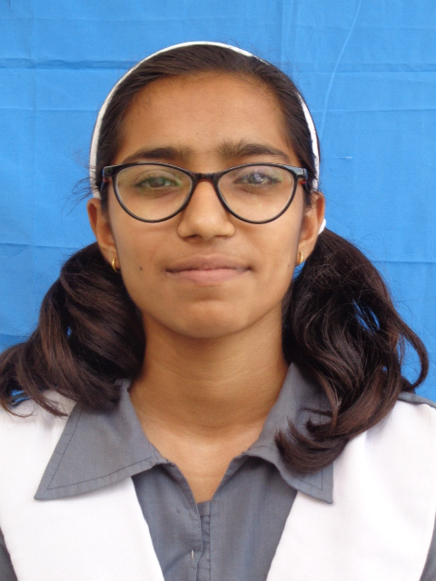
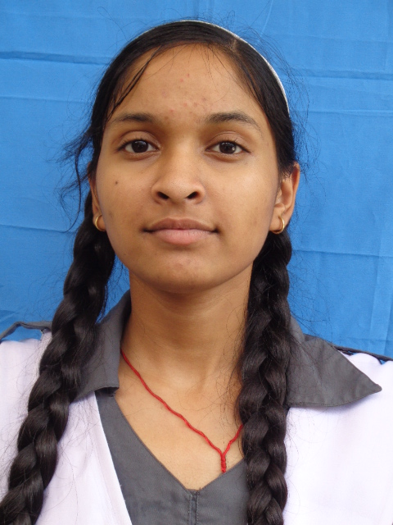
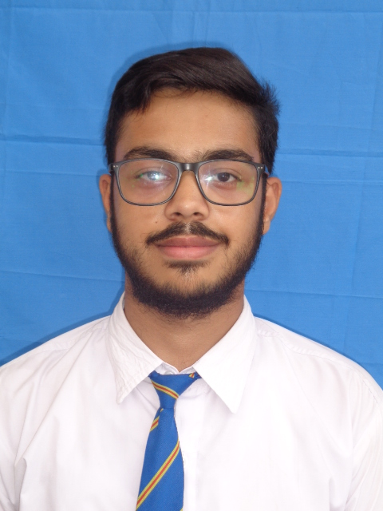
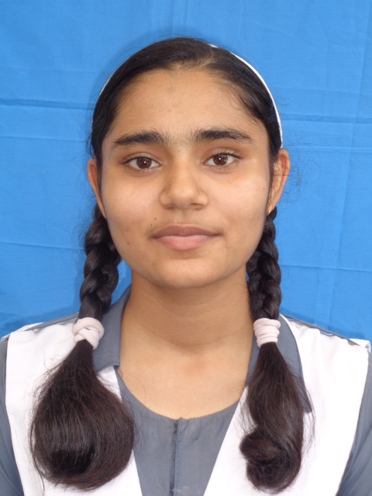

Nishi Rajput Mahi Mangal Divyansh Namdev Kanishka
(96.80%) (96.20%) (95.00%) (95.00%)
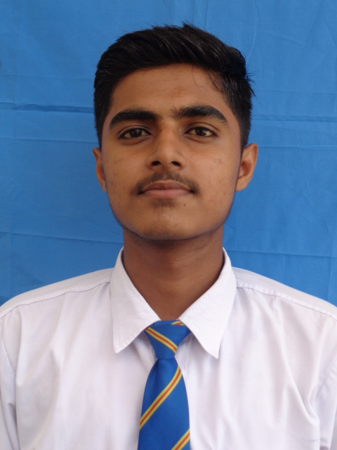
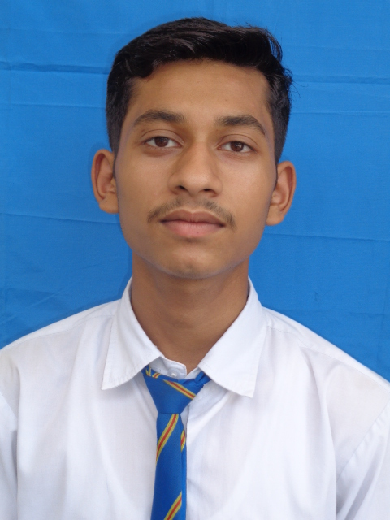
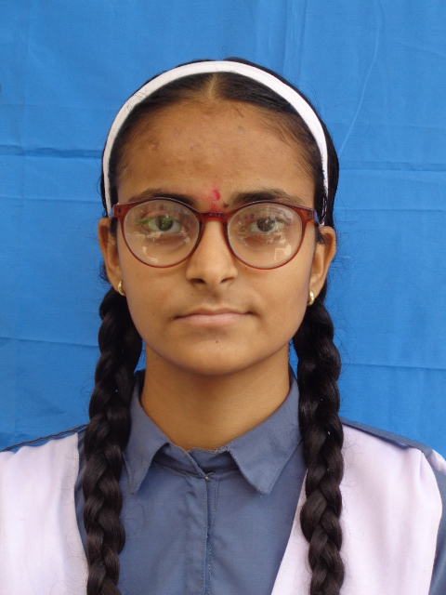
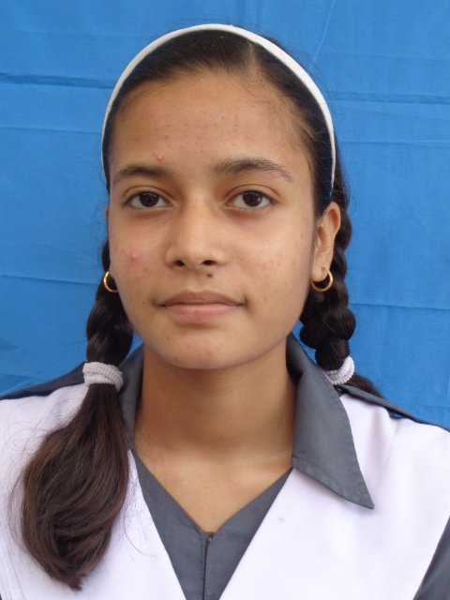

Anshul Rajput Anubhav Gupta Netra Chaudhary Kshiti Sharma
(94.80%) (94.40%) (92.60%) (92.40%)
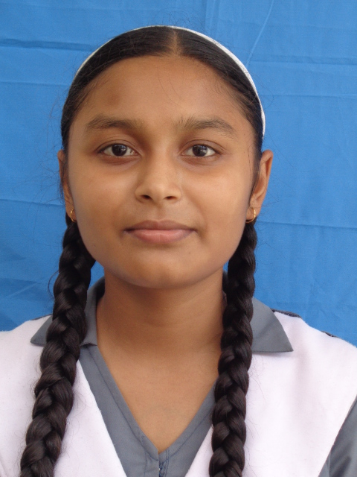
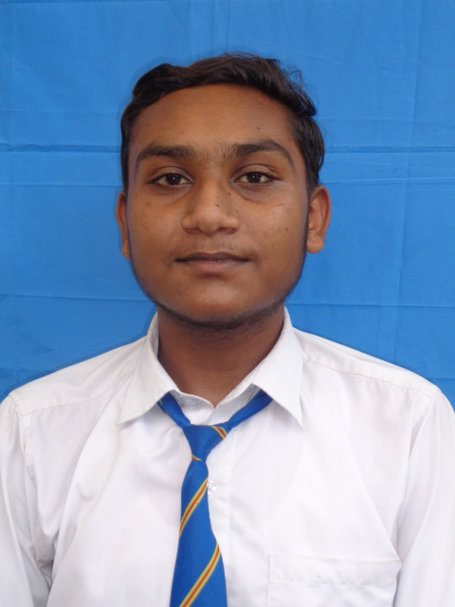

Nikun Chauhan Pranav Kumar Rana
(92.40%) (92.00%)

Commerce Toppers:

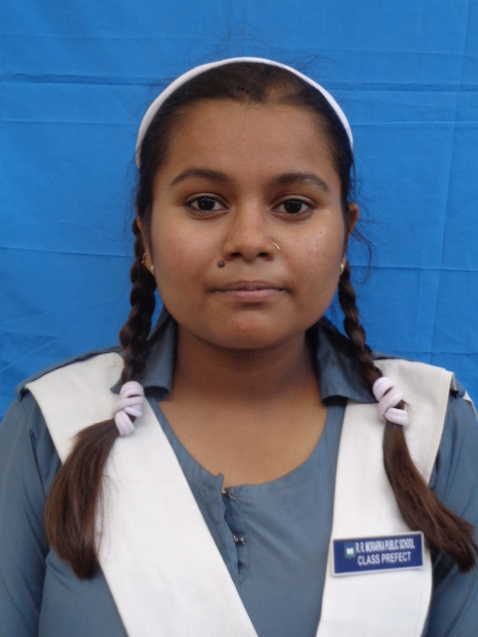
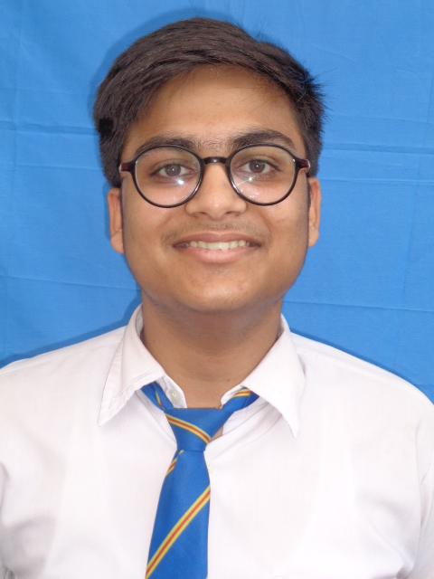


Divyam Agarwal Dhruvika Bishnoi Arth Agarwal Shivam Muthreja
(96.60%) (95.00%) (92.00%) (91.00%)
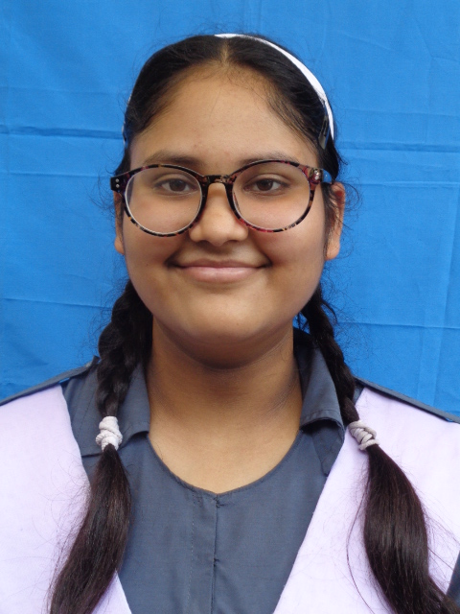
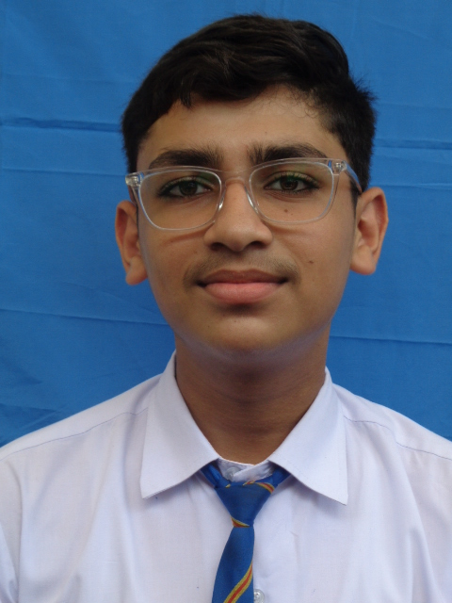

Jhanvi Agarwal Vatsal Jain
(90.80%) (90.80%)

