R.R. MORARKA PUBLIC SCHOOL, DWARIKESH NAGAR
CLASS X (SSE): 2023
Sr. | Roll No. | Candidate's Name | SEX | English (184) | Hindi (002) | Maths (041) | SCIENE | Soc Sc (087) | IT (402) | Total Excluding IT
1 | 25162988 | BHAWESH KUMAR AGRAWAL | M | 97.00 | 95.00 | 100.00 | 95.00 | 100.00 | 100.00 | 487.0 | 97.40 | I
2 | 25162990 | GAURI JUYAL | F | 96.00 | 94.00 | 97.00 | 99.00 | 98.00 | 100.00 | 484.0 | 96.80 | II
3 | 25163064 | VINAYAK AGRAWAL | M | 97.00 | 96.00 | 97.00 | 100.00 | 94.00 | 100.00 | 484.0 | 96.80 | II
4 | 25162981 | AKSHARA AGARWAL | F | 93.00 | 95.00 | 96.00 | 96.00 | 97.00 | 100.00 | 477.0 | 95.40 | IV
5 | 25163035 | BHUSHAN TOMAR | M | 92.00 | 95.00 | 98.00 | 97.00 | 95.00 | 97.00 | 477.0 | 95.40 | IV
6 | 25162992 | JAPLEEN KAUR | F | 94.00 | 95.00 | 95.00 | 95.00 | 97.00 | 100.00 | 476.0 | 95.20 | VI
7 | 25163055 | SHORYA KUMAR | M | 96.00 | 95.00 | 96.00 | 93.00 | 95.00 | 97.00 | 475.0 | 95.00 | VII

CLASS X (SSE): 2023
Highlights: 34 STUDENTS OUT OF 87 secured 90% AND ABOVE
ALL PASS – NO FAIL – NO COMPARTMENT
Subject Toppers

Subject Code | Subject | No. of Candidates Appeared | Highest Marks | Name OF Students
184 | English | 87 | 97 | BHAWESH KUMAR AGRAWAL, VINAYAK AGRAWAL
002 | Hindi | 76 | 96 | VINAYAK AGRAWAL
122 | Sanskrit | 11 | 95 | AMRITA RAO
041 | Mathematics | 87 | 100 | BHAWESH KUMAR AGRAWAL,  KSHITIJ VERMA
086 | Science | 87 | 100 | VINAYAK AGRAWAL
087 | Social Science | 87 | 100 | BHAWESH KUMAR AGRAWAL
462 | INFORMATION TECHNOLOGY | 87 | 100 | BHAWESH KUMAR AGRAWAL, GAURI JUYAL, VINAYAK AGRAWAL, AKSHARA AGARWAL, JAPLEEN KAUR, ANJALI SINGH, SAVI PANDEY, VANSHIKA JAIN, VRINDA AGARWAL, ABHINAV CHAUDHARY, AKSHIT DAVAS, RITIK KUMAR, VARTIKA RAJPUT

No. of Students Appeared = 87
Passed = 87
90% and above = 19 STUDENTS

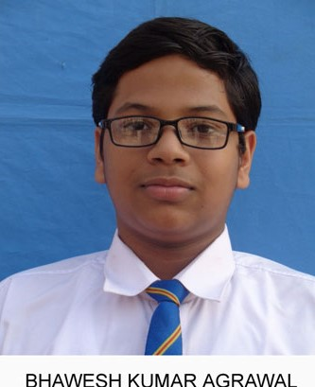
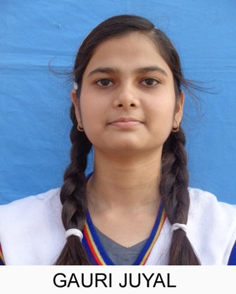
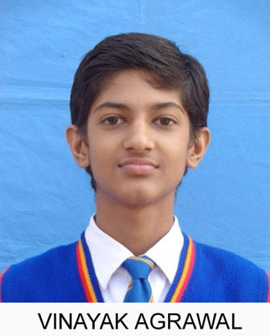
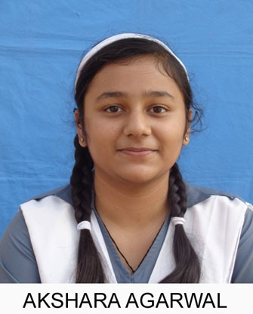
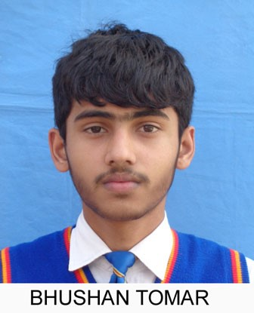

(97.40%) (96.80%) (96.80%) (95.40%) (95.40%)

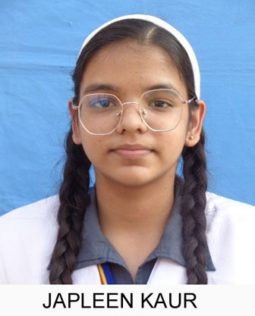
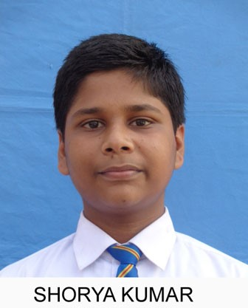

(95.20%) (95.00%)

