R.R. MORARKA PUBLIC SCHOOL, DWARIKESH NAGAR, DIST. BIJNOR
CBSE BOARD RESULTS CLASS XII – 2021
Toppers in Science Stream:
Roll No | Name | EN-C | PHY | CHE | Maths | BIO | IP | PHE | Total | % | Rank
 |  | 100 | 100 | 100 | 100 | 100 | 100 | 100 | Total | % | Rank
1 | NANDINI JAIN | 99.00 | 96.00 | 96.00 | -- | 99.00 | -- | 99.00 | 489.00 | 97.80 | I
2 | AASHISH KUMAR | 99.00 | 96.00 | 97.00 | 96.00 | -- | 98.00 | -- | 486.00 | 97.20 | II
3 | SHANTANU KUMAR | 99.00 | 96.00 | 96.00 | 96.00 | -- | 99.00 | -- | 486.00 | 97.20 | II
4 | SWAPNIL TYAGI | 98.00 | 96.00 | 97.00 | 96.00 | -- | -- | 98.00 | 485.00 | 97.00 | III
5 | HARSHDEEP SHARMA | 96.00 | 96.00 | 98.00 | -- | 99.00 | -- | 95.00 | 484.00 | 96.80 | IV
6 | VASU AGARWAL | 99.00 | 96.00 | 96.00 | 96.00 | -- | 96.00 | -- | 483.00 | 96.60 | V
7 | APOORV SINGH BHANDARI | 96.00 | 96.00 | 96.00 | 97.00 | -- | 97.00 | -- | 482.00 | 96.40 | VI
8 | EAKANSH AGARWAL | 96.00 | 96.00 | 96.00 | 96.00 | -- | 98.00 | -- | 482.00 | 96.40 | VI
9 | SHORYA AGARWAL | 99.00 | 96.00 | 96.00 | 96.00 | -- | 94.00 | -- | 481.00 | 96.20 | VII
10 | AHMAD SUFIYAN | 97.00 | 95.00 | 96.00 | -- | 95.00 | -- | 95.00 | 478.00 | 95.60 | VIII
11 | ANSH KUMAR | 96.00 | 95.00 | 96.00 | 96.00 | -- | -- | 95.00 | 478.00 | 95.60 | VIII
12 | VEDITA JOSHI | 99.00 | 96.00 | 87.00 | -- | 98.00 | -- | 98.00 | 478.00 | 95.60 | VIII

R.R. MORARKA PUBLIC SCHOOL, DWARIKESH NAGAR, DIST. BIJNOR
CBSE BOARD RESULTS CLASS XII 2021

Toppers in Commerce Stream:
Roll No | Name | EN-C | ECO | BST | ACC | IP | Maths | PHE | Total | % | Rank
Roll No | Name | 100 | 100 | 100 | 100 | 100 | 100 | 100
1 | RAKSHIT BHATT | 99.00 | 97.00 | 99.00 | 98.00 | -- | 99.00 | -- | 492.00 | 98.40 | I
2 | SAMRIDDHI AGARWAL | 97.00 | 96.00 | 96.00 | 95.00 | 94.00 | -- | -- | 478.00 | 95.60 | II
3 | NANDINI KALRA | 95.00 | 95.00 | 96.00 | 96.00 | 94.00 | -- | -- | 476.00 | 95.20 | III
4 | PAVNI AGARWAL | 98.00 | 97.00 | 98.00 | 96.00 | -- | 86.00 | -- | 475.00 | 95.00 | IV

R.R. MORARKA PUBLIC SCHOOL, DWARIKESH NAGAR, DIST. BIJNOR
Students appeared in AISSCE (XII) Examination 2020:
No. of students in Science Stream: 44
No. of students in Commerce Stream: 31
No. of students obtained 90 % and above: 24 out of 75
Subject Toppers
Subject | Subject | No. of | Highest | Name
Code | Subject | Candidates | Awarded | Name
301 | English Core | 75 | 99 | NANDINI JAIN, ASHISH KUMAR, SHORYA AGARWAL, SAMRIDDHI AGARWAL, VEDITA JOSHI, KARAN GAUTAM
42 | Physics | 44 | 96 | NANDINI JAIN,AASHISH KUMAR,SHANTANU KUMAR,SWAPNIL TYAGI,HARSHDEEP SHARMA,VASU AGARWAL,APOORV SINGH BHANDARI,EAKANSH AGARWAL,SHORYA AGARWAL,VEDITA JOSHI,KARAN GAUTAM,VIPASHA TOMAR,
43 | Chemistry | 44 | 98 | HARSHDEEP SHARMA
41 | Mathematics | 40 | 99 | RAKSHIT BHATT
44 | Biology | 11 | 99 | NANDINI JAIN, HARSHDEEP SHARMA
54 | Business Studies | 31 | 99 | RAKSHIT BHATT
55 | Accountancy | 31 | 98 | RAKSHIT BHATT
30 | Economics | 31 | 97 | RAKSHIT BHATT, PAVNI AGARWAL
65 | Informatics Practices | 33 | 99 | SHANTANU KUMAR
48 | Physical Education | 35 | 99 | NANDINI JAIN, VIPASHA TOMAR

R.R. MORARKA PUBLIC SCHOOL, DWARIKESH NAGAR, DIST. BIJNOR
CBSE BOARD RESULTS CLASS XII 2020
CLASS XII (AISSCE): 2020
No. Of Distinction Holders (Subject Wise)

SR. | SUBJECT | STUDENTS APPEARED | >=75
1 | English Core | 75 | 74
2 | MATHEMATICS | 40 | 30
3 | CHEMISTRY | 44 | 30
4 | PHYSICS | 44 | 39
5 | INFORMATICS PRACTICES | 33 | 30
6 | PHYSICAL EDUCATION | 35 | 32
7 | BIOLOGY | 11 | 11
8 | ACCOUNTANCY | 31 | 20
9 | BUSINESS STUDIES | 31 | 28
10 | ECONOMICS | 31 | 22

Toppers Class XII :2021
Science
  (I Position -97.80% ) |   (II Position – 97.20%) |   (II Position – 97.20%) |   (III Position – 97.00%) |   (IV Position – 96.80%)

(V Position – 96.60%) |   (VI Position -96.40%) |   (VI Position -96.40%) |   (VII Position -96.20%) |   (VIII Position -95.60%)

  (VIII Position -95.60%) | 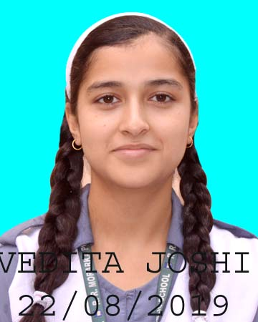  (VIII Position -95.60%)

Commerce

  (I Position - 98.40%) |   (II Position - 95.60%) | 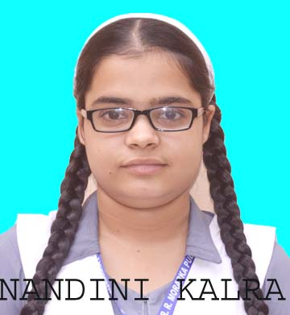  (III Position - 95.20%) | 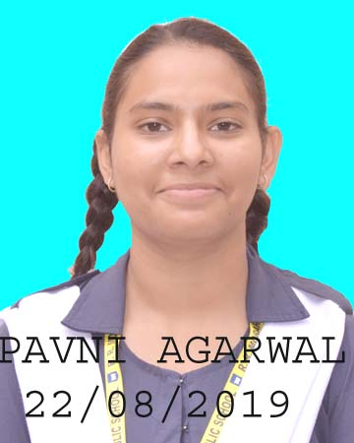  (IV Position – 95.00%)

